Love dies on an Avocado Tree
for solo cello and human drama
By Jing Jing Luo 2018

ALL RIGHTS & INTERNATIONAL RIGHTS RESERVED C ASCAP/LUO 2018

PERFORMANCE NOTES

use a dried walnut shell and scrape on one string up and down

use the walnut shell and roll up and down on four strings

shriek and whimper; this sign indicates a high, piercing, short and
whistle-sound like in the upper register and near the
bridge; use the tip of the bow

one-quarter tone flat

one-quarter tone sharp

move from normal to harmonic trills

move rapidly upward from a normal glissando to the highest harmonic for one second
then glissando downward to normal

your choice of artificial or natural harmonic

normal to heavy pressure bow

move from normal, at outset, to extreme fast bowing, between normal and sul pont.

sliding a plastic binder up and down on the string (hysterically
and spontaneously)

E.M.V. = extreme molto vibrato
M.S.P. = extreme sul ponticello
wet finger squeak on wood, on the front or the back of the
instrument

bundle a few avocado seeds with a string bouncing on all strings

knock on wood with index finger (knuckle)

mimic human speaking voice (dramatically)

fast and airy ricochet preferably in the higher registers region

col legno with wood near the bridge, soft, airy and swiftly (as of a
broom quietly swiping the wind)

insert a large sized comb binding in between the C, G strings (see
images below)

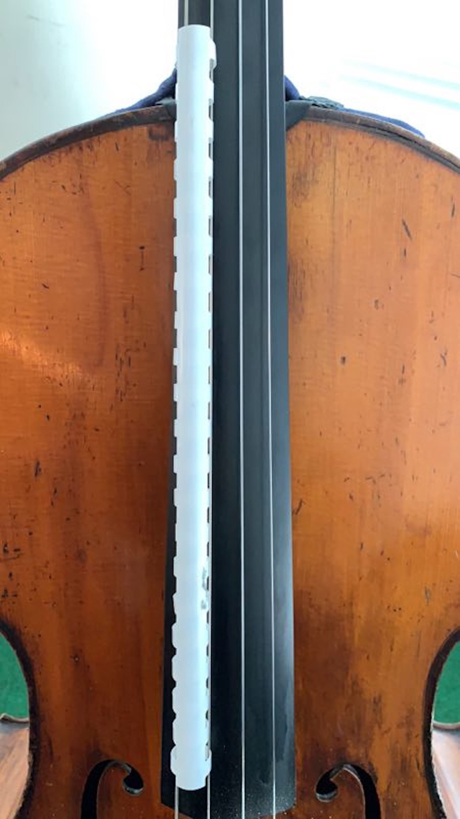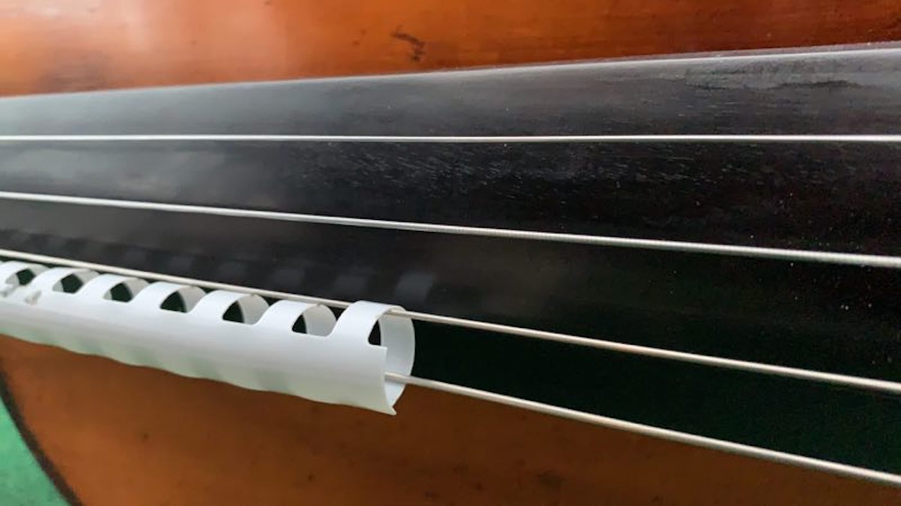

the 9 multiphonics used in this piece are sourced from the website http://www.cellomap.com

videos instructing how to perform all the multiphonics above can be viewed here --
http://www.cellomap.com/index/the-string/multiphonics-and-other-multiple-sounds.html

Program Note

Love dies on an Avocado tree 2018
Commissioned and dedicated to Fang Yijia
for solo cello and human drama

On the right side of our ship,
Your soft gaze penetrated my body.
The vanilla scent invaded me with silence,
I was melting in your blue...

You left like a feather, shutting the cabin door,
As we floated in the Pacific Ocean.

I said goodbye in the City at midnight,
Face to face, never again.
Time has drifted away – my departed.

In dreams, I seek your breath with thirst;
Your arms become the branches
surrounding my forbidden fruit.
Why did you tell me you want me, and all of me?
but it was never real...
Seeds, planted deep in a heart, do not grow with spit and rock.
I could have loved you a thousand times and a thousand years!
but you are not strong enough to have me.

The avocado tree wilted at dawn,
Blue, greenish leaves now brown.
Sweetness turns to pungent.
I bury my tears in the cold ground...

Love dies on an avocado tree.

poem written by Jing Jing Luo
Love dies on an avocado tree 2018
for solo cello and human drama

The piece explores a sonic architecture through various intricate
patterns, gestures, vocalizations, timbres and juxtapositions to
express and expose the dark side of human emotion and desires. The
journey of particular sound makes you feel as if you are wandering around
in an elusive maze; you are excited, you are shocked, you get lost
and you are foiled by your own false moves.
To me, cello is the countertenor that reflects both the voice of Devine
masculinity and femininity in one. The higher register region of the
instrument acts as a female voice. I wrote this piece particularly
with the image in mind of a man who sings in a woman's voice as in
the Beijing Opera in China, and as in Baroque opera.

Jing Jing Luo

